20XX-01-XXXX
Type the Title of Your Paper Here
Author, co-author (Do NOT enter this information. It will be pulled from participant tab in MyTechZone)
Affiliation (Do NOT enter this information. It will be pulled from participant tab in MyTechZone)

Abstract
Before starting your paper, please read, “How to Write an SAE International Technical Paper,” (http://volunteers.sae.org/authors/sae_tech_paper.pdf) for specific instructions related to the content of your paper. This template is merely a tool to aid you in submitting your manuscript. Your final published paper will not look exactly as you submit it as page layout may make it necessary to reposition figures and tables. The template’s sample elements (headings, figures, tables, etc.) have been formatted to the SAE Technical Paper Style Guide which can be used as an additional resource (http://volunteers.sae.org/authors/styleguide.pdf). When you are ready to upload your final manuscript, remember to use the Technical Paper Checklist (http://volunteers.sae.org/authors/checklist.pdf) before submitting your paper. This will ensure that all steps have been completed and are correct. Before starting your paper, this template should be printed as a reference and all the text beginning after the abstract heading should be deleted. Please keep the following in mind when developing your abstract:
- Abstract MUST be one paragraph and between 250-300 words.
- The paper is the authoritative source for the abstract.
- Footnotes, figures, tables, and equations cannot be included in the abstract (or title).
Introduction
The [Head1] style is a Level 1 heading. It has been applied to the “Abstract” and “Introduction” headings. A [Head1] is 12 point, initial caps, bold. [Normal] style text and other levels of headings ([Head2], [Head3], and [Head4]) should be used to structure the content within any given section.
First Heading of Body
The body of the paper should include detailed and structured description of the work performed, including (as appropriate) methodology, assumptions, hardware, observations, analysis, and a comparison of results with prior work. The information presented must be self-contained (in the sense that the reader is not assumed to have read prior papers) and provide an appropriate level of detail for the intended audience. Define all terms at first usage and apply them consistently.
The body section is not entitled “Body.” Rather it comprises multiple sections and subsections titled using topical headings in a four-level structure. Template styles [Head1] through [Head4] are used to tag and format titles of the different levels. No specific heading titles are mandated, but common examples include Methods, Results, and Discussion. The [Normal] style tag is used for paragraph text. Figures, tables, and equations fall under the body section. Found in this template are examples of a figure, a table, and equations (which must be kept to 3.5 inches wide).
Head 2 Example
A [Head 2] style tag applied to the heading above is 11 point, initial caps, bold, italic. The [Normal] style tag should be used for paragraph text which is 9 point, regular.
Head 3 Example
A [Head3] style tag applied to the heading above is 10 point, initial caps, bold. The [Normal] style tag should be used for paragraph text which is 9 point, regular.
Head 4 Example
A [Head4] style tag applied to the heading above is 9 point, initial caps, bold, italic. The [Normal] style tag should be used for paragraph text which is 9 point, regular.
Table 1. This is an example of a table and table title. For tables, the recommended size is 3.5 inches. Table titles are 8 point, SAE Blue, and are placed above the table. The Normal Table Text style tag should be applied to the table text.
Displaced volume | 1966 cc
Stroke | 154 mm
Bore | 127.5 mm
Connecting Rod | 255 mm
Compression ratio | 14.3:1
Number of Valves | 4
Exhaust Valve Open | 34° BBDC @ 0.15 mm lift
Exhaust Valve Close | 6° BTDC @ 0.15 mm lift
Inlet Valve Open | 2° BTDC @ 0.15 mm lift

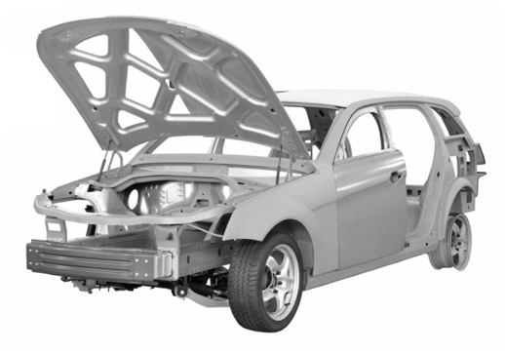
Figure 1. Example of a figure and figure caption. The sample figure has been sized to 3.5 inches wide, which is the recommended size. Captions for figures are 8 point, SAE Blue, and are placed below the figure.
- This is an example of an ordered list. When creating this type of list do not enclose number or letter in parentheses i.e., (1) or (a). Instead number as shown in this example.
Shown are examples of equations. All equations wider than 3.5 inches must be wrapped to the next line as shown in equation 2.
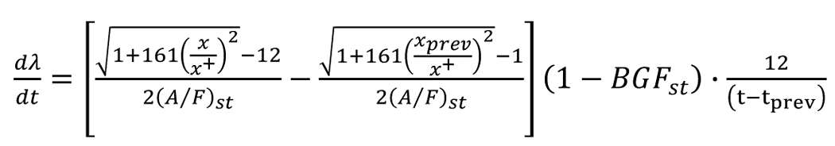
(1)
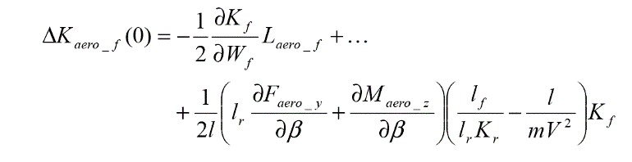
(2)
Summary/Conclusions
If the Summary/Conclusions section is not wanted, delete this heading and text.
References
- SAE uses the Chicago Manual of Style in formatting references. In the text of the paper the citations are numerically identified using square brackets [1]. Up to four authors should be listed; more than four, et al. should be used after the fourth author is listed. Refer to the SAE Technical Paper Style Guide for formatting of different types of references. Apply the List-Ordered-Numeric style tag to format references. Below are some examples.
- Guo, Q. and Liu, B., "Simulation and Physical Measurement of Seamless Passenger Airbag Door Deployment," SAE Technical Paper 2012-01-0082, 2012, doi:10.4271/2012-01-0082.
- Kunkel, S., Zimmer, T., and Wachtmeister, G., "Friction Analysis of Oil Control Rings during Running-In," SAE Technical Paper 2011-01-2428, 2012, doi:10.4271/2011-01-2428.
- Morgan, R., Scullion, P., Nix, L., Kan, C. et al., "Injury Risk Investigation of the Small, Rear-seat Occupant in Side Impact," SAE Technical Paper 2012-01-0092, 2012, doi:10.4271/2012-01-0092.
- Kimura, Y. and Murakami, M., "Analysis of Piston Friction - Effects of Cylinder Bore Temperature Distribution and Oil Temperature," SAE Int. J. Fuels Lubr. 5(1):1-6, 2012, doi:10.4271/2011-01-1746.
- SAE International Surface Vehicle Recommended Practice, “Laboratory Measurement of the Composite Vibration Damping Properties of Material on a Supporting Steel Bar,” SAE Standard J1637, Rev. Aug. 2007.
Contact Information
Contact details for the main author should be included here. Details may include mailing address, email address, and/or telephone number (whichever is deemed appropriate).
Acknowledgments
If the Acknowledgments section is not wanted, delete this heading and text.
Definitions/Abbreviations
SA | sample abbreviations
UBT | Use borderless table ≤ 3.5 inches wide.
test vector | Don’t capitalize term unless an acronym or proper noun.

Appendix
The Appendix is one-column. If you have an appendix in your document, you will need to insert a continuous page break and set the columns to one. If you do not have an appendix in your document, this paragraph can be ignored and the heading and section break deleted.

